Pokhara University

Level: Bachelor | Semester – Fall | Year : 2008
Programme: BE |  | Full Marks : 100
Course: Integrated Digital Electronics |  | Time : 3hrs.

Candidates are required to give their answers in their own words as far as practicable.
The figures in the margin indicate full marks.

Attempt all the questions.

1. | - A BJT inverter is driving N loads. With the following specifications, calculate the max fan-out N and design the inverter.  V_{CC} = +5V  V_{OH} = 3.5V at I_{OH} = 5mA  V_{IH} = 3.5V at I_{IH} = 1mA  - The gate G0 has a fan-out of 5. Plot the transfer characteristic for the gate G0. Calculate Δ1 and Δ0 noise margins.  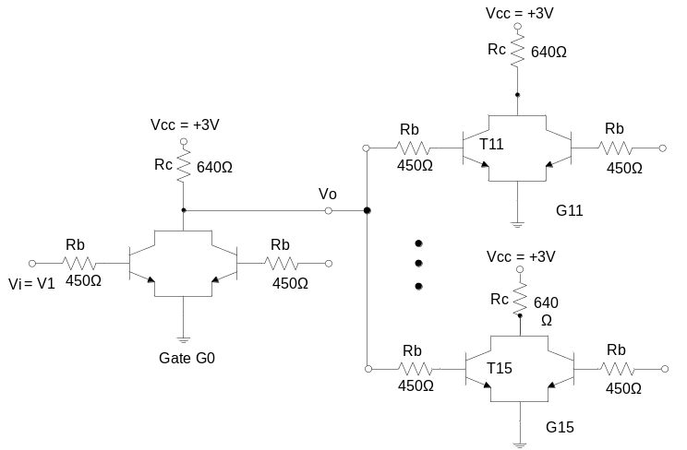 | 7  8
2. | - Derive the expression for fan out for the standard DTL NAND gate  - The output of the gate V_{o2} is to be fanned out to N similar gates. Find N at room temperature if the ∆1 noise margin is to be 0.3V.  Given: Rc2 = 360Ω; Re = 1.8KΩ; RE = 940Ω; VEE = -5.7V  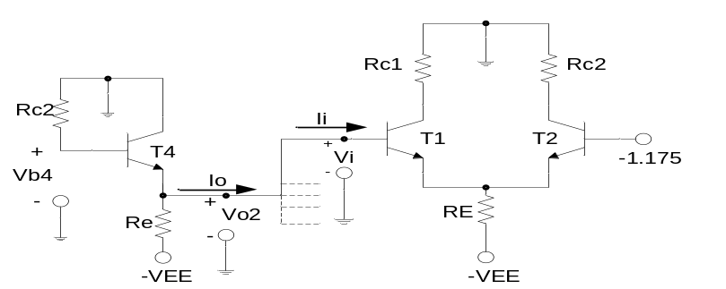 | 7  8
3. | - Write the VHDL code for full adder.  - What is open collector configuration in relation to a TTL gate? State its advantage.  - In the following circuit, A, B, C and D are the inputs to the gates. If the gates used are TTL determine the output of the circuit and state the reason.  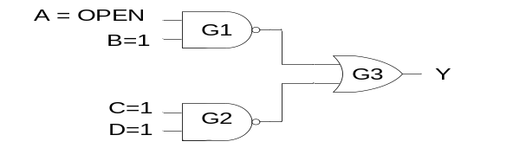 | 5  5  5
4. | - Explain the CCD, the storage and transfer of charge mechanism in CCD.  - Explain the application of switch in an integrate and dump circuit. | 8  7
5. | - In an industrial system, a CMOS NAND gate is meant to drive TTL loads. What are the specifications that the designer should take into consideration for a successful interface?  - Draw the circuit diagram of a static MOS cell.  - Calculate the gain for a 2-diode transmission gate. | 5  5  5
6. | - In a bottling company, it is desired to count the number of bottles filled. Write a VHDL code to implement the counting system that can count up to 16 bottles in a batch.  - A combinational circuit accepts 4 inputs, write the VHDL code for the circuit such that it detects maximum number of 1’s in the input. | 8  7
7. | Write short notes on (Any Two)  - How does the power dissipation of MOS gates vary with (i) input frequency (ii) load capacitance and (iii) supply voltage? Explain.  - Draw a 2 input CMOS NOR gate and 2 input CMOS NAND gate.  - Propagation delay | 5×2

